A PROJECT DOCUMENTATION ON “ONLINE JOB APPLICATION MANAGEMENT SYSTEM”

AYOMIDE OLUWOLE

INTERSWITCH ID: AOHCSO01774

NOVEMBER, 2022

INTERSWITCH ACADEMY

TABLE OF CONTENTS

PROBLEM STATEMENT……………………………………………………………………………3

AIM AND OBJECTIVES, SCOPE AND CHALLENGES…………………………………………..7

SOFTWARE DEVELOPMENT LIFE CYCLE ………………………………………………………9

APPLICATION SOFTWARES, FRAMEWORK, DATABASE……………………………………...10

DESIGN DIAGRAMS ..………………………………………………………………………………12

CODING (SAMPLE & SAMPLE SCREENSHOTS) ………………………………………………..14

TESTING AND IMPLEMENTATION……………………………………………………………….15

FUTURE ENHANCEMENT AND CONCLUSION………………………………………………....17

CHAPTER ONE

PROBLEM STATEMENT

This section of the documentation deals with the Background and general overview of the whole project, Requirements, as well as Benefits of the project.

Background/Overview:

In recent times, manner of living and daily operations in doing things such as acquisition of goods, transportation, application for jobs, rendering of services etc have all taken a new turn in their processes due to the “new normal”- the COVID-19 emergence. The emergence of the COVID-19 outbreak called for a forced lockdown and shutdown of minor to major operations all around the world, with movements and manner of communication being restricted. This shift has since caused most businesses and services to change their mode of operations by adopting the process of either Physical, Virtual or a combination of both, commonly referred to as the Hybrid method. With this change or turn in events, many have experienced loss in different ways, one area where the emergence of COVID-19 took a big toll was in the area of white- and blue-collar jobs.

According to research, the pandemic and resulting lockdown caused about 100 million people world-wide to lose their jobs over the year 2020. Applications such as Zoom, gained a much wider audience in communications and holding meetings due to its ability to accommodate people amongst all other features. Other software applications in existence also increased in users’ registration and signups in order to conveniently work-from-home and earn while working multiple jobs. Two of these popular applications are Upwork and Fiverr. In this application, individuals are able to have a profile setup and post what services they offer as well prices attached to these services.

National and local-wise, a new *pandemic “broke-out”,* the Academic Staff Union of Universities, popularly known as ASUU, went into an eight-months strike which affected the Federal Universities in the country. This situation has since rendered most students and their lecturers inactive, taken away their source of livelihood and put most in the state of confusion as to what to do next and how long the strike would take. The current situation has since forced many to look for alternate sources of livelihood (where the skill set is readily available), but in most cases remain stuck with the hope that things would change as quickly as it started.

Another case to note relates to the unskilled labourers who, in most cases, have in one way or the other undertaken a detailed and not so detailed training and are looking for ways to set themselves up professionally in their respective business(es). With no assistance, guidance or link to the right platforms or jobs, they are as well unemployed and their training also useless (as most employers of labour are actively searching for people with experience and formal training). With this, study has shown the issue of unemployment is a big deal and the lack of the right knowledge gained from training and its applicability has led to students and all involved to live a low lifestyle.

PROJECT BENEFITS:

The benefit of this project includes but not limited to:

1. It is cost effective and reduces the time wasted in physically searching for jobs that fits an individual profile and skills.
2. Reduce the level of unemployment and increase the productivity of individuals.
3. Improve livelihood of individuals in the society.
4. No middle-man presence or delay in response/feedback regarding the employment as reactions and actions are immediate.
5. Improvement in the skill sets of individuals who sign up for Trainings on the application.
6. Provides access to Digital Information.

PROJECT REQUIREMENTS:

The requirements of a software project can be divided into two subsections, the first being the Functional and Non-Functional Requirements which focuses on what the system is set to do or achieve and its features or characteristics, the other subsection is the Software and Hardware requirements. These requirements focus on what tools were used in the execution of the project as well as the necessary technologies needed in replicating the application amongst users.

FUNCTIONAL AND NON-FUNCTIONAL REQUIREMENTS:

The functional requirements for this project are as follows:

1. This system authenticates and authorises users’ access to features based on their roles, policies, and permissions.
2. The system verifies and validates users input in real time when inputting users information.
3. The system filters jobs based on the category selected.

The non-functional requirements of this project are as follows:

1. The application can handle multiple users due to the large storage space of the database in use.
2. Usability – The system adopts the ease-of-use feature as it takes into consideration user experience and satisfaction.
3. The speed of the system is adequate, due to the type of technology used – Entity Framework, enough for the retrieval of information. But this does not cause lags in giving responses to users as expected.

SOFTWARE AND HARDWARE REQUIREMENTS:

The hardware requirements for this project includes:

1. Laptop with the following specifications: Processor Intel(R) Core(TM) i5-8265U CPU @ 1.60GHz,, 4 Core(s), 8 Logical Processor(s).

The software requirements are as follows:

1. Windows Operating System (8 and above),
2. Database software: Microsoft SQL Server Management Studio 18
3. PC Web - Browser - Chrome
4. Visual Studio 2022

CHAPTER TWO

AIM AND OBJECTIVES, SCOPE, CHALLENGES AND SCHEDULE/TIME FRAME.

This section of the project focuses on what the sole purpose or aim of the project is, that is, the reason for this project, as well as outlines its objectives. It also provides a scope that it functions in while specifying some of the challenges in carrying out the project.

AIM OF PROJECT:

The aim of this project is to develop an online platform that connects skilled and unskilled individuals to opportunities around them and also offer training to those willing to upgrade their knowledge base or transition to a different more lucrative career or business.

OBJECTIVES OF THE PROJECT:

The objectives of this project is outlined as follows:

1. To develop a platform that rightfully connects skilled/unskilled job seekers to opportunities around them.
2. To offer different training to those who are willing to upgrade their skills professionally.
3. To make Jobs easily available to almost “anyone”, “anyhow” and “anytime”.
4. To reduce the level of unemployment and increase the productivity of individuals.

SCOPE OF THE PROJECT:

The scope of the project refers to the area in which the project would focus on. This project would solely focus on Acquisition of Job opportunities to individuals interested **and** qualified. Its focus would also be on training of individuals who are either not or properly trained in their set skill and are willing to register for the feature.

CHALLENGES:

The challenges involved in the creation of this project involves dynamically getting jobs from job sites, filtering, sorting the jobs dynamically based on the user's choice and inputs. Also, challenges arose as a result of trying to combine two DBContext whilst using the same databases in order to allow for easier querying.

SCHEDULE/TIME FRAME:

The tabular representation below gives an overview of the courses taken that led to the creation of the project:

| MONTH | WEEK 1 | WEEK 2 | WEEK 3 | WEEK 4 |
| --- | --- | --- | --- | --- |
| SEPTEMBER | COURSES TAKEN  (C, C++, OOP, DOCUMENTATION etc) | COURSES TAKEN  (C, C++, OOP, DOCUMENTATION etc) | COURSES TAKEN  (C, C++, OOP, DOCUMENTATION etc) | COURSES TAKEN  (C, C++, OOP, DOCUMENTATION etc) |
| OCTOBER | COURSES TAKEN,  PROJECT DISCUSSION | COURSES TAKEN,  CREATION OF ER DIAGRAMS | Continuous learning based on choice of course selected (C#) | Continuous learning based on choice of course selected (C#) |
| `NOVEMBER | Continuous learning on technologies to be used in Project | Knowledge gained in courses taken relating to Project | Commencement of Project with technologies defined | Continuous implementation of project |

CHAPTER THREE

SOFTWARE DEVELOPMENT LIFE CYCLE

Software Development Life Cycle is a process or series of steps that help guide the development of a product or project from the initial stage to its finishing stage. It involves the continuous development of software through the phases contained in the chosen life cycle. The SDLC phases consists of six (6) to seven (7) phases:

* Requirement gathering and analysis
* Design
* Implementation or Coding
* Testing
* Deployment
* Maintenance

The SDLC chosen for this project is that of the Agile Methodology. Agile SDLC is one of the many types of SDLC available, amongst which others are Waterfall, V, Iterative etc. The Agile Methodology was chosen in order to achieve the iterative process involved with continuous delivery of users changing needs which then helps in accommodating risks.

The advantages of this model includes but not limited to:

* Allows for changes - flexibility in adapting to changes and delivery of tasks in dynamic form.
* Speed and adaptability
* Allows for collaboration.

CHAPTER FOUR

APPLICATION SOFTWARES, FRAMEWORK, DATABASE

This part of the project discusses the Application softwares used in executing the project, details and functionalities. The Application Softwares used are:

1. WEB BASICS (HTML/CSHTML, CMSS, JAVASCRIPT): Web basics refer to the programming languages used in creating web pages, the said web pages could be static or dynamic depending on the technologies used. HyperText Markup Language, commonly referred to as HTML is a markup language that provides the structure of the web pages with the use of tags understood by the browser, so be it text or images you want rendered in the browser, HTML is the language for it. CSHTML, is a spin off the ‘normal/tradition’ HTML as it is a C# HTML language that is used at server side by Razor Markup Engine, it enables dynamic web content creation.

CSS, the acronym for Cascading Style Sheet, is another web technology language that allows for styling the elements written with HTML tags via the classes and IDs used in distinguishing each element having the same tags.

JAVASCRIPT language provides functionalities or ‘actions’ to styled elements, this allows for interaction within the webpage or application. In providing these functionalities to certain aspects of the application, the IDs and classes are also selected with the method - getElementsById/getElementsByClassName/getElementsByName/getElementsbyTagName or query selectors.

1. ASP.NET MVC CORE: This is an open source and lightweight framework optimised for use with ASP.NET Core, it allows for the development of dynamic websites with components having defined structure, use and process definition based on the introduction of MVC. MVC stands for Model-View-Controller. It is an architectural pattern that divides software applications into three parts: Model, View, Controller. The Model focuses on the application data and behaviour in terms of the problem domain, and independent of the User Interface (UI), it interacts with the databases and executes business logic. The View represents the HTML markup that is displayed to the user while the Controller is responsible for handling an HTTP Request, takes user inputs(request parameters) and interacts with the Model and View. Router selects the right controller to handle the request.
2. MSSQL MANAGEMENT STUDIO: This is a software application that manages SQL (Structured Query Language) infrastructure. It helps in configuring, managing and administering components within the SQL Server. For this project, MSSQL Management Studio was used in storing the tables which represent the entities, for example Users (the individuals registered on the system), Roles, Jobs, Trainings etc.
3. ENTITY FRAMEWORK CORE: Entity Framework (EF) is a full featured Object Relational Mapper (ORM), which helps in mapping object related programs, that allows for Migration, Caching, Relationships amongst tables in the databases as well as Designer, which allows you create Models and set relationship between objects. Entity Framework (EF) Core is an open source cross-platform technology based on the EF structure. EF Core was used in the project to help create the database to be used as well as the various tables available in the database via the “Code-First” and Scaffolding approach. It helps in reducing the number of lines of data access code that needs to be written.
4. DOTNET IDENTITY: The ASP.NET Identity tool is another application used in this project to help automatically create pages such as Accounts Login, Logout and Register. These pages could also be modified based on Layouts used, structure, styles etc. It can be said to be “Is an API that supports user interface (UI) login functionality”.
5. C#: This is an object-related programming language that runs on .NET Framework. It can be used in creating and developing web applications, desktop games, web service applications, database applications etc.

CHAPTER FIVE

DESIGN DIAGRAMS

This area gives a pictorial view of the design diagrams used in defining and explaining concepts related to the project, some of the design diagrams used are: Unified Modelling Language, also known as UML where the Use Case Diagram was selected from the other types of diagrams it provides. Also, the Entity Relation Diagram and Database Schema were represented.

USECASE OF SYSTEM:

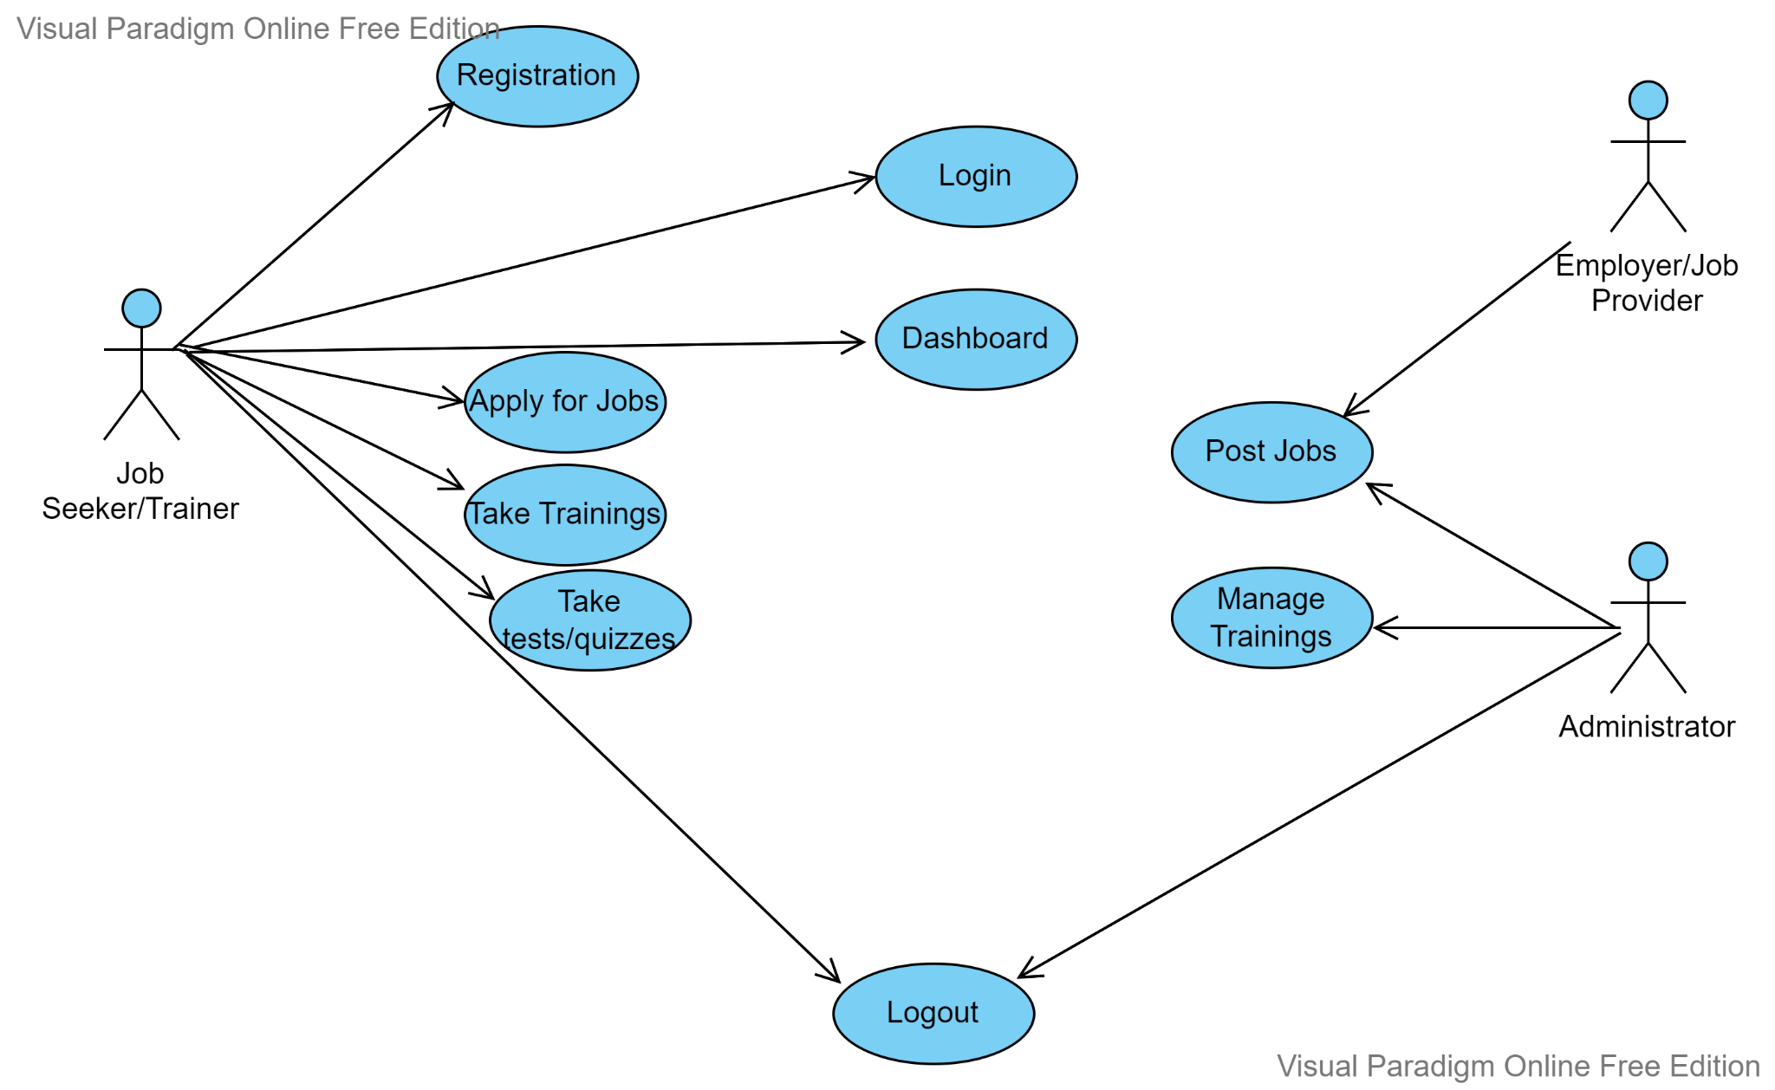

ER SCHEMA:

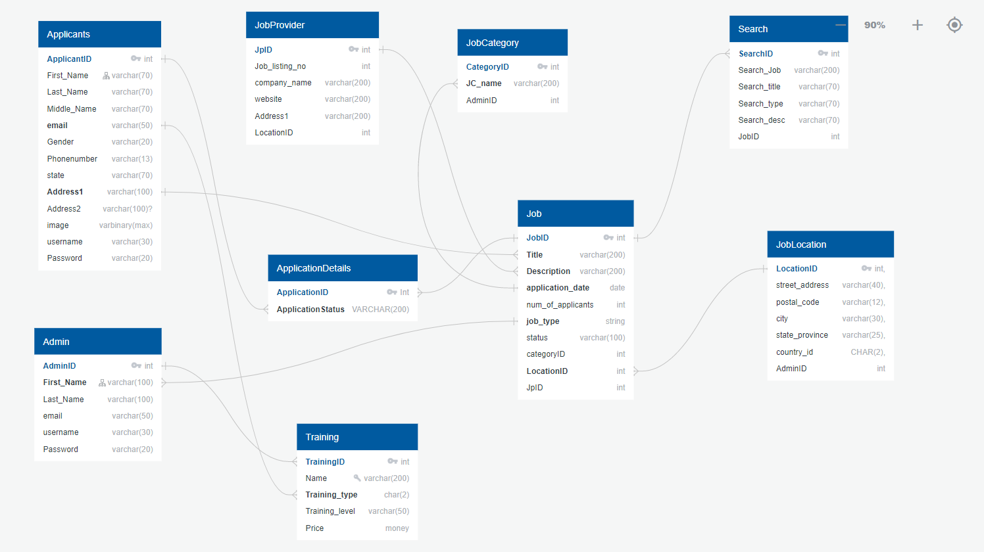

ER DIAGRAM:

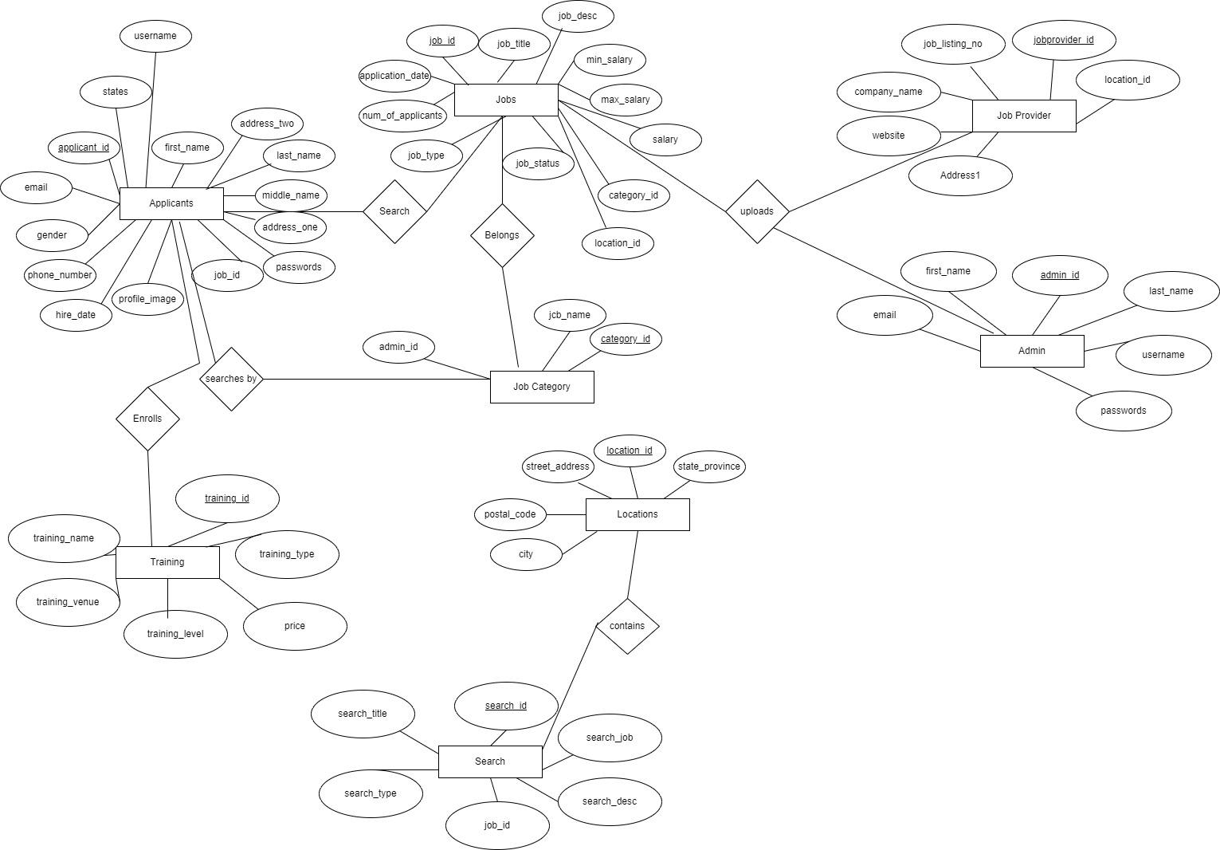

CHAPTER SIX

CODING

GITHUB LINK: <https://github.com/RhodAyo/ISW-TASK>

CHAPTER SEVEN

TESTING (TEST CASES) AND IMPLEMENTATION

Testing is a crucial part of any Software either in development or in complete phase. Testing allows for components or modules of the application (desktop, web, android etc) to be verified against certain measures in order to discover defects or mishaps in each of the components. This is a continuous process especially for applications in development, for those applications which are completed, testing can be done in terms of performance, usability etc.

In this project, application testing is performed via the different categories:

* GUI Testing: The Graphical User Interface (GUI) Testing focuses more on the usability and users interactiveness with the application. In terms of its usability, verification is done by validating its requirements when considering the inputs and expected outputs. Some of the examples used in this testing involves:

1. Testing Inputs of users, for example, in cases like emails, text boxes required, length of names etc.
2. Testing users are able to provide input to input fields based on their types, such as Passwords which would be asterisked as it is sensitive, numbers entered in the form of figures and not texts etc.

For users' interactiveness, the use of feedback was provided in cases where the user makes requests or input their information in order to alert users on a successful or unsuccessful transaction, for example, when a user registers, makes a request to apply for a job/training etc.

* Load and Performance Testing: This testing was carried out to determine the speed and time at which the system loads and presents information to users based on the software used, people registered on the system as well as amount of modules used in its creation. The performance for this application based on the Object Relational Rapper (Entity Framework) is around 0.631 seconds unlike applications that make use of Micro ORMS, which performs better at 0.04 seconds.
* Roles and Rights Testing: This is another testing carried out with this application, the use of AlloyAnonymous, Authorize, Policy and Roles were implemented in order to ensure certain users of the system do not have access to certain features, for example, a user should not be able to login as an admin or add new users etc.
* Database testing: This testing is done with the use of SQL queries, it focuses more on testing inputs entered into tables, columns, validating data duplication. Database testing is equally important as it helps to allow information entered as they are expected based on data types and constraints and this helps in saving data loss, also allows for no unauthorized access to information etc.

CHAPTER EIGHT

FUTURE ENHANCEMENT AND CONCLUSION

FUTURE ENHANCEMENT:

Due to time limitation and the evolving of the project, this project still has some outstanding requirements which includes:

* Selection of Jobs and Trainings,
* The use of faster ORMs to help improve the performance and load time.

CONCLUSION:

This web application has been designed and developed using a number of development tools i.e HTML, CSS , Javascript, C#, sql database, asp.net core. The application has been developed to provide the solution for job and training applications..